Assessment effects high interest rate for sustainable energy sector
Date 06/12/2023

Companies in the sustainable energy sector are suffering from higher interest rates.
In 2022, the ECB began raising interest rates in response to increased inflation. At the time of broadcasting this assessment, the ECB's refi-rate (the rate banks must pay to the ECB when borrowing money) was at 3%; since May 4th, it has already increased to 3.75%. The ECB's interest rate hikes started in July 2022, prior to which the rate had been at 0% or even negative. This ECB refi-rate strongly influences the interest rates that banks charge for their own loans. In a brief assessment, the NVDE surveyed its members to gauge the extent to which they are experiencing the effects of this interest rate increase.

One third of the companies are already experiencing adverse effects on their financing options due to higher interest rates (see Figure 1). And more than one third of the companies currently do not experience these effects but anticipate difficulties in the near future. The increased costs of borrowing/investment are particularly cited as an effect of the higher interest rates. Several companies also note changes in the financing mix of their business and/or investment. Another significant adverse effect of the higher interest rates is the postponement or cancellation of projects, experienced by almost a third of the companies.
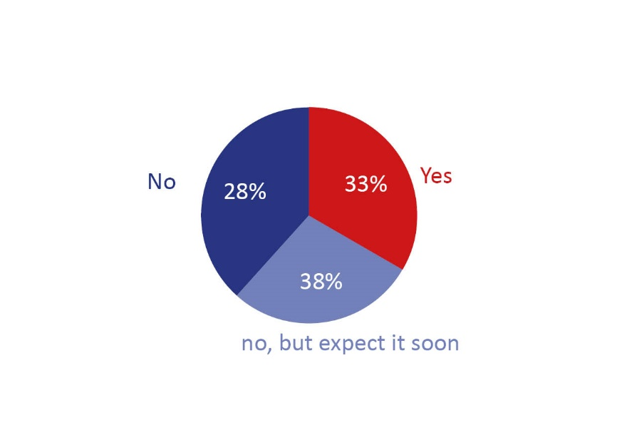
Figure 1: Response to the question ‘Have the increases of the interest rates had a negative effect on your financing options?’

Impact of higher interest rates on project business cases
The business case for projects depends on multiple factors, with costs and returns playing a significant role. The increased costs resulting from higher interest rates could therefore have a significant impact on the business case. When asked about the overall expectations for project business cases, more than half still indicate a positive or moderately positive outlook (see Figure 2).

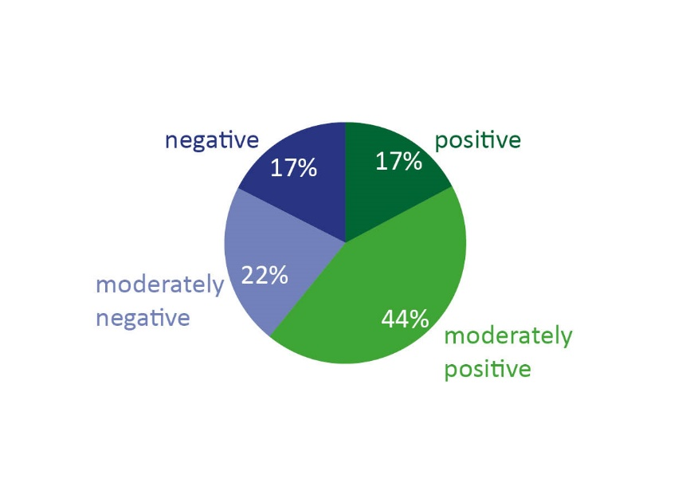
Figure 2: Response to the question ‘What are your overall expectations for the business case of (your) projects?’

It remains challenging to provide expectations for the business case, given the numerous factors that can fluctuate. Recently, costs have significantly increased, including financing costs due to higher interest rates, as well as more expensive materials and higher wages. However, revenues have also increased due to higher energy prices. How both will develop in the future is to some extent uncertain, but it is likely that interest rates will remain high and may even continue to rise to combat inflation.

The assessment also specifically inquired about the effect of higher energy prices on the expectations for project business cases. This is because energy prices have soared as a result of the war in Ukraine. On September 1st, 2022, there was a peak in the average gas price at €3.921 (€/m3) and the average electricity price at €0.860 (€/kWh). Since then, prices have decreased but still remain significantly higher than in the recent past, although they have returned to the levels of early 2022. While most of the companies indicate that higher energy prices generate higher revenues and promote sustainability and efficiency, other companies point out that increased energy prices have a negative impact on the business case for their projects due to higher costs.

Delay in the energy transition
A concerning picture emerges from the responses to the question about expectations regarding the impact of high interest rates, energy prices, and other market conditions on the (potential) delay of the energy transition and the set goals for 2030. More than 80% indicate that they foresee moderate or severe delays (see Figure 3).

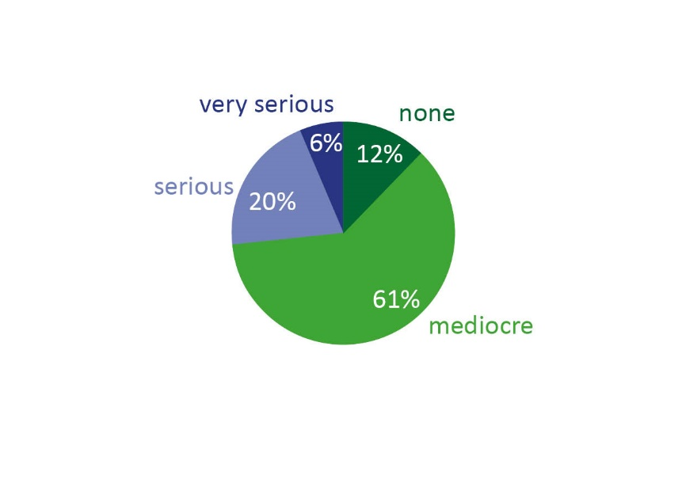

Figure 3: Response to the question ‘Do you expect that the high interest rate, energy price, and other market conditions will delay the energy transition and the set goals for 2030?’

Funding mix of companies and projects
The responses indicate that financing for both the companies themselves and their projects consists of a diverse mix of equity and debt. Due to the diversity of financing options, and answers, it is difficult to draw conclusions from them. However, what stands out is that the majority of debt financing comes from bank loans, which are naturally affected by the rising interest rates. Therefore, it is not surprising that when asked if the costs of debt financing changed in the second half of 2022 compared to the first half of 2022, more than half of the respondents indicate that they have increased by 1% or more. The significant impact of the rising interest rates on financing concerns is also evident in the 43.2 percent of respondents who attribute the increased Weighted Average Cost of Capital (WACC) solely to the higher interest rates.

Nearly half of the companies expect an increase in revenue in the first half of 2023
Forty-six percent of the companies stated that their revenue in the first half of 2023 is expected to be higher compared to the same period in 2022. Twenty-seven percent stated it would be the same, and the rest anticipated a decrease. The higher revenue will likely be driven largely by higher energy prices and increased demand for sustainable products, both of which contribute to higher revenue. However, higher revenue does not necessarily indicate the ultimate profit and financial situation of companies, as the (higher) costs will still have a significant impact.

Method of assessment
The purpose of this assessment is to provide an overview of the impact of higher interest rates on sustainable investments in the sustainable energy sector. Interest rates have significantly increased over the past year, and it is clear that this has implications for the financing of renewable energy projects. The Nederlandse Vereniging Duurzame Energie (NVDE), together with its affiliated branches, surveyed what companies are experiencing in terms of the higher interest rates and their impact on the energy transition. The information can be brought to the attention of policymakers by the NVDE, and they will make proposals to minimize the effects of these interest rate increases on investments in the sustainability of our energy system. The number of respondents for this assessment is 49, and the questionnaire was completed in March/April 2023.

